## Hackathon Project Phases Template for the Flavour

## Fusion AI- Driven Recipe Blogging

# 0Hackathon Project Phases Template

**Project Title:**

Flavour Fusion: AI-Driven Recipe Blogging

**Team Name:**

Nova Nexus

**Team Members:**

* Syed Suhana
* Pogula Pavitra
* Sirisilla Ronith

## Phase-1: Brainstorming & Ideation

**Objective:**

The goal of the brainstorming and ideation phase is to generate, explore, and evaluate innovative concepts for a system that observes, analyses, and responds to weather patterns

**Key Points:**

1. **Problem Statement:**

People often struggle with meal planning based on weather conditions. There is a need for a smart, weather-based recipe suggestion system that helps users decide what to cook based on current weather.

1. **Proposed Solution:**

* **Weather-Based Recipe Suggestions:**

Enter a city name to get weather based recipe recommendations.

1. **Target Users:**

* Home Cooks looking for meal ideas based on weather.
* Health-Conscious Individuals seeking seasonal and nutritious meals.
* Busy Professionals who want quick and easy weather-friendly recipes.
* Travelers needing food suggestions based on the climate of their location.
* Restaurants & Cafés wanting to offer weather-based menu options.

1. **Expected Outcome:**

* Personalized Recipe Suggestions (e.g., warm soup for rainy days, cold desserts for hot weather).
* Weather & Mood-based Pairing (Tea with snacks on a cloudy day, energy-boosting meals in cold weather)..

## Phase-2: Requirement Analysis

**Objective:**

The primary objective of the requirement analysis is to identify, gather, and document the functional and non-functional requirements for developing an AI-powered system that provides food suggestions based on real-time weather conditions

**Key Points:**

1. **Technical Requirements:**

○ Programming Language**: Python**

○ Backend: **Google Gemini Flash API**

○ Frontend: **HTML, CSS**

○ Database: **Not required initially (API-based queries)**

1. **Functional Requirements:**

* **Recipe Filtering:** Suggest meals based on weather (e.g., hot soup in cold weather, smoothies in summer).
* **Meal Scheduling:** Allow users to plan meals based on future weather forecasts.

.

1. **Constraints & Challenges:**

* **Weather Data Accuracy** – Reliance on third-party APIs may lead to inaccuracies or delays...
* **AI Personalization** – Balancing accurate recommendations with computational efficiency.
* . **Real-time Weather Adaptation** – Adjusting suggestions quickly for sudden weather changes.
* **External System Integration** – Seamless connection with inventory services.
* **User Engagement** – Retaining users with interactive and relevant content.
* . **Data Privacy & Security** – Ensuring user data protection while suggestions

## Phase-3: Project Design

**Objective:**

The project aims to design an AI-powered system that offers food suggestions based on real-time weather conditions, enhancing user experience through intelligent recommendations.

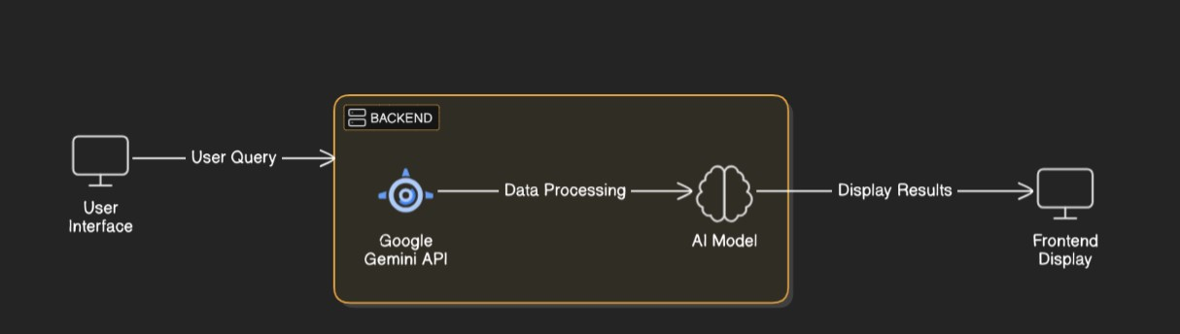

**Key Points:**

1. **System Architecture:**

* **Data Layer:**

**Weather Data Source:** Real-time weather APIs (e.g., Open Weather Map, Weather stack).

**Recipe Database:** A structured database for storing

* **Processing Layer:**

**AI/ML Models:**

**Weather-Food Mapping Model:** Correlates weather patterns with suitable food types.

**Recommendation Engine:** Personalizes suggestions based on user history and current weather.

**Data Processing:** Cleans and formats weather and recipe data for analysis.

* **Application Layer:**

**Backend:** Manages API calls, user requests, and AI processes.

**Frontend:** Provides the user interface for browsing, searching

.

1. **User Flow:**

Homepage → place Input → Weather Detection → Recipe suggestions

1. **UI/UX Considerations:**

**UI:** Clean design.

**UX:** Simple navigation, fast food suggestions, recipe recommendations, and accessibility feature

## Phase-4: Project Planning (Agile Methodologies)

**Objective:**

Break down development tasks for efficient completion.

|  |  |  |  |  |  |  |  |
| --- | --- | --- | --- | --- | --- | --- | --- |
| **Sprint** | **Task** | **Priority** | **Duration** | **Deadline** | **Assigned To** | **Dependencies** | **Expected**  **Outcome** |
| Sprint 1 | Environment Setup  & API Integration | 🔴 High | 6 hours  (Day 1) | End of Day  1 | Suhana | AI model, java, cloud set up | AI model connecting and running |
| Sprint 1 | Frontend UI Development | 🟡  Medium | 2 hours  (Day 1) | End of Day  1 | Pavitra | API response format finalized | Basic UI with weather input fields |
| Sprint 2 | AI-recipe suggestion integration | 🔴 High | 3 hours  (Day 2) | Mid-Day 2 | Suhana Pavitra | API model, UI elements ready | AI suggests recipes based on inputs |
| Sprint 2 | Error Handling &  Debugging | 🔴 High | 1.5 hours  (Day 2) | Mid-Day 2 | Suhana &Ronith | API logs, user input validation | Improved AI stability |
| Sprint 3 | Testing & UI  Enhancements | 🟡  Medium | 1.5 hours  (Day 2) | Mid-Day 2 | Pavitra &Ronith | AI response, layout completed | Responsive UI, better user experience |
| Sprint 3 | Final Presentation  & Deployment | 🟢 Low | 1 hour  (Day 2) | End of Day  2 | Entire Team | Working prototype | Demo-ready project |

**Sprint Planning with Priorities**

**Sprint 1 – Setup & Integration (Day 1)**

🔴 **(High Priority)** Set up the development environment & install dependencies.

🔴 **(High Priority)** Integrate AI model for weather based recipe suggestion.

🟡 **(Medium Priority)** Build a basic UI with input fields for weather and preferences.

**Sprint 2 – Core Features & Debugging (Day 2)**

🔴 **(High Priority) Implement** **AI recipe suggestion**— suggest weather based recipes based on user inputs.

🔴 **(High Priority) Debug AI issues** — handle errors in weather combinations and invalid inputs

🟡 **(Medium Priority) Add search and filter options** —weather based suggestions

**3 – Testing, Enhancements & Submission (Day 2)**

🟡 **(Medium Priority) Test AI responses** — ensure suggestions are accurate, unique, and relevant.

🟡 **(Medium Priority) Refine UI —** improve layout, add food suggestions and enhance user interaction.

🟢 **(Low Priority) Final presentation and deployment) —** prepare a demo-ready blog with sample AI-suggested foods.

## Phase-5: Project Development

**Objective:**

Develop a weather-based food suggestion system that uses real-time weather data and AI to recommend, ensuring fast, accurate, and user-friendly experiences.

**Key Points:**

1. **Technology Stack Used:**

* **Frontend:** HTML,CSS
* **Backend:** GOOGLE GEMINI FLASH API
* **Programming Language:** PYTHON

1. **Development Process:**

**Sprint 1:** Environment setup, AI integration, basic UI.

**Sprint 2:** AI food suggestion, search/filter features, debugging.

**Sprint 3:** Testing AI, refining UI, deployment.

**Version Control: Git**/GitHub

1. **Challenges & Fixes:**

* **Real-time Data Integration: Weather API delays —** use reliable APIs with caching strategies.
* **AI Accuracy: Poor meal suggestions —** train models with diverse weather-food datasets.
* **User Engagement: Low interaction —** add feedback options and personalized filters.
* **Scalability:** Performance issues — optimize code and use cloud solutions for data handling.

.

## Phase-6: Functional & Performance Testing

**Objective:**

**Functional Testing Objective:** Verify the system suggests accurate meals based on real-time weather data.s

**Performance Testing Objective**: Ensure fast meal recommendations with minimal response time.

|  |  |  |  |  |  |
| --- | --- | --- | --- | --- | --- |
| **Test Case ID** | **Category** | **Test Scenario** | **Expected Outcome** | **Status** | **Tester** |
| TC-001 | Functional  Testing | Query "suggest food to eat in pune weather " | Relevant food suggestion should show | ✅ Passed | Suhana |
| TC-002 | Functional  Testing | Query " show food in Mumbai weather” | Food suggestion is showed. | ✅ Passed | Pavitra |
| TC-003 | Performance  Testing | AI response time under  500ms for city basd food suggestion | Ai should suggest food quickly. | ⚠ Needs Optimization | Ronith |
| TC-004 | Bug Fixes & Improvements | Fix AI for wrong food suggestion | AI suggest logical foods | ✅ Fixed | Suhana |
| TC-005 | Final Validation | Ensure AI suggestions update with real time city weather | Suggestion should be unique yet logical. | ✅ passed | Pavitra |
| TC-006 | Deployment  Testing | Deploy app on cloud | Blog should be accessible online. | 🚀 Deployed | DevOps |

## Final Submission

1. **Project Report Based on the templates**
2. **Demo Video (3-5 Minutes)**
3. **GitHub/Code Repository Link**
4. **Presentation**